Fly Dressers Guild
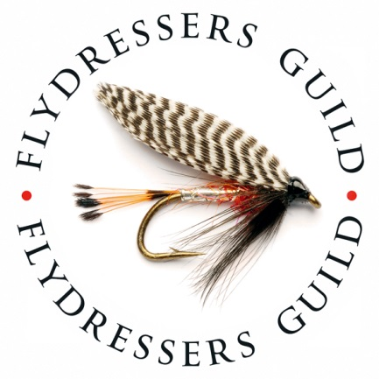

Elinor Bank competition 21st May 2023
Our 2023 Elinor Bank competition will be held on the Sunday 21st May at Elinor Trout fishery, Kettering. This is a very friendly day out enjoyed by all the regular entrants.. A great way to meet up with fellow Guild members.
This year we are going to award the winning trophies at the fishery & have hot food catered for at the fishery. For added comfort please bring a folding chair..
Registration & rules.
All competitors MUST be current members of the Fly Dresser’s Guild & MUST hold a current EA Rod licence.
All competitors must register with the organiser by 8.30am on the morning of the competition.
Fishing will start at 9.30 or as soon as registration is complete and end at 5pm.
Anglers may kill the first 4 fish and thereafter catch and release a further 8 fish
The winning angler and winning team will be the one with most fish. In the event of a tie, the weight of the first 4 fish will decide the outcome.
There will be prizes for the winning team of 3, best bag and largest fish.
Any fish caught and released must be unhooked in the net and witnessed by another competitor. Anglers will have a card to record their C&R catches. This should be initialled by the witnesses if practicable
The Match will be fished on a “Roving” basis. Anglers are NOT to hog one spot and team members should not fish side by side.
Phones to be used in emergency only please. No communication by mobile phone with team members will be allowed.
Fishing will be by fly fishing only, with up to 4 flies allowed The use of the bung or other indicator is allowed as is “roly poly” retrieve
Once a limit of 4 fish has been killed the angler may catch and release a further 8 fish to a total of 12 fish
Anglers must keep their fish separate from those of other anglers. All killed fish must be removed from the fishery by the captor.
Catch and release must be with barbless or crushed barb hooks only.
Catch and release No buoyant flies on sinking lines A washing line set up on a floating line is allowed.
All catch and release fish must be netted and unhooked in the water to count. Assistance is allowed.
Wading is permitted but not within 25 yards of another angler. Wade with consideration and in safety.
A maximum of two rods may be assembled and rigged at any time
All anglers must carry an approved landing net
Please remember this is an event aimed at bringing together the members of the Guild in friendly competition. Please be considerate towards your fellow members.
Any questions, please contact Lee Hooper on fishing@flydressersguild.org

